|  |  |
| --- | --- |
|  | AUSTRALIAN HIGH COMMISSION  DHAKA |

**Australia helps Bangladesh assess its water resources**

Australia and Bangladesh yesterday hosted a workshop on water resources in Bangladesh.

The workshop follows four years of collaborative research between Australia’s Commonwealth Scientific and Industrial Research Organisation (CSIRO) and the Bangladesh Government, supported by Australia’s regional aid program for South Asia.

The *Bangladesh Integrated Water Resources Assessment* provides an overview of Bangladesh’s surface and ground water, and assesses the impact of economic development and climate change on water availability.

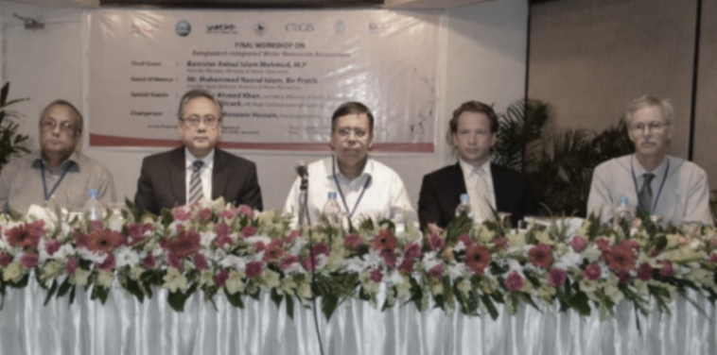

*From left to right: Muhammad Nazrul Islam,Bir Protik, Honorable State Minister, Ministry of Water Resources, Mr Anisul Islam Mahmud, M.P, Honorable Minister, Ministry of Water Resources, Dr Azfar Ahmed Khan, Secretary, Ministry of Water Resources, Mr Greg Wilcock, the High Commissioner of Australia to Bangladesh, and Dr Mac Kirby, Principal Research Scientist and the Project Leader, CSIRO Land and Water, Canberra*

Australian High Commissioner Greg Wilcock accompanied Water Resources Minister Anisul Islam Mahmud and State Minister Muhammad Nazrul Islam during the event.

Mr Wilcock welcomed the project as a tangible, practical demonstration of scientific cooperation between Australia and Bangladesh.

“Australia and Bangladesh have vastly different landscapes, but we both face water scarcity and can learn from each other,” Mr Wilcock said. “I hope this project lays the basis for further collaboration between us.”

**Australian High Commission, Dhaka**

**8 May 2014**

For further information please contact

Senior Research and Communications Officer

Australian High Commission.

Tel: 8813105, Ext 413, E-mail: aditi.nigar@dfat.gov.au